ProMarkers are high-quality, alcohol-based markers widely used by illustrators, designers, and artists for their vibrant colours, smooth application, and versatility. ProMarkers are valued for their ability to produce professional results in everything from graphic design and illustration to fashion sketches and fine art. Their alcohol-based ink ensures quick drying times, minimal streaking, and consistent colour application, making them ideal for both detailed work and broad colour fields.

**Tools you need when working with promarkers**

* Promarker or copic marker set
* Appropriate paper
* Cotton bud
* Pencil and eraser
* Ruler

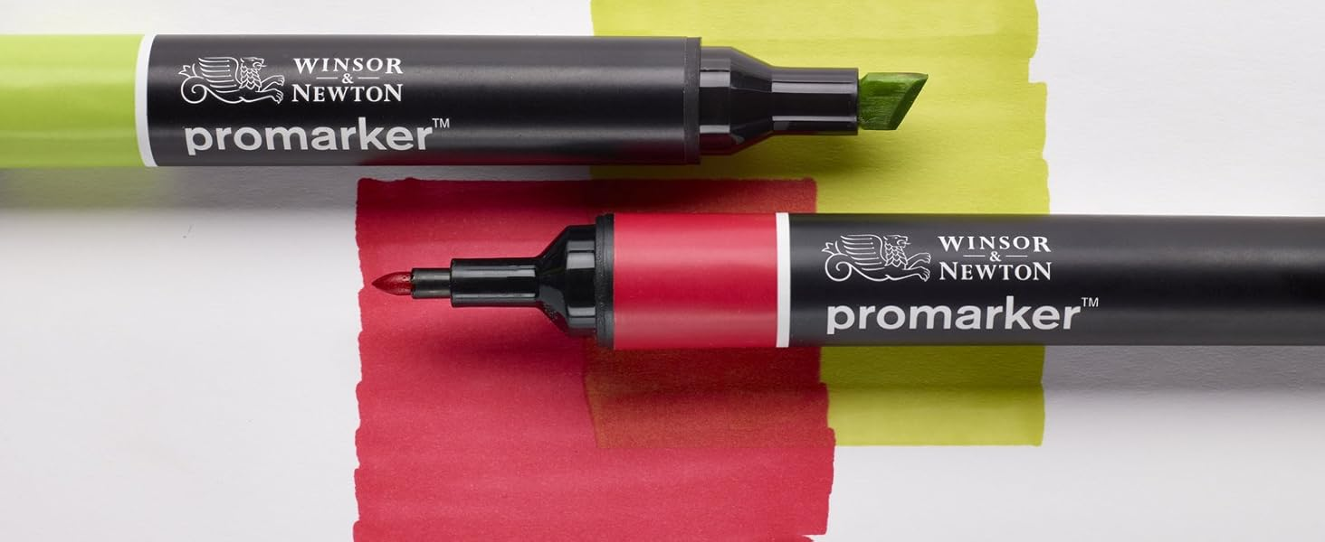

Fig. 1. Amazon (n.d), Promarkers [photo]

## Paper

Using the correct paper is vital. If you apply a promarker to ordinary cartridge paper it will give a poor result and can soak through sheet after sheet or onto whatever surface is underneath. In addition, when you apply a promarker onto the wrong type of paper it can creep or bleed over the sheet and outside the line or edge you created.

In order to prevent such a problem, buy a good quality bleed proof marker pad. The paper is coated on one side meaning it will not bleed through to the sheet below or allow the marker to spread across the sheet. Using bleed proof paper will give the optimum colour result. Each colour will appear rich and vibrant with a maximum tonal variation.

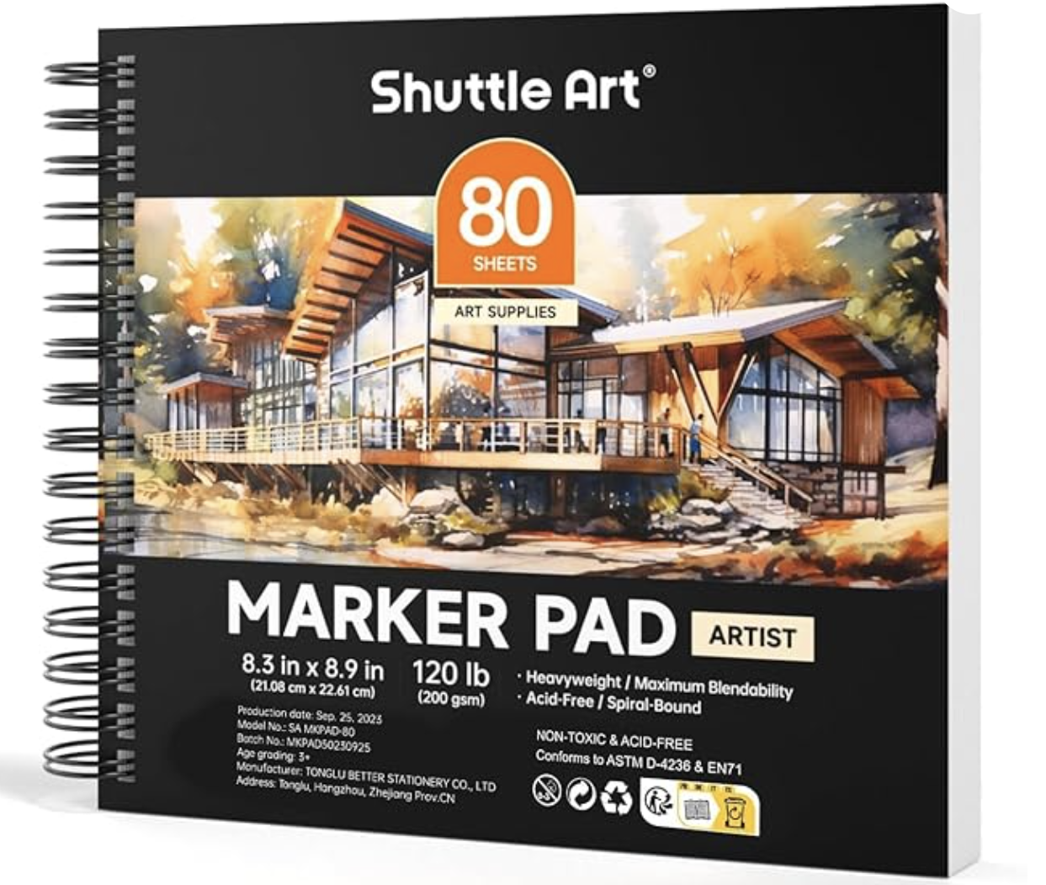

Fig. 2. Amazon (n.d.), Promarker paper

## Tria marker

Each promarker will contain a nib at either end of the marker, i.e. chisel and brush nib. The Tria is the only marker with a third nib, which is the ultra fine nib.

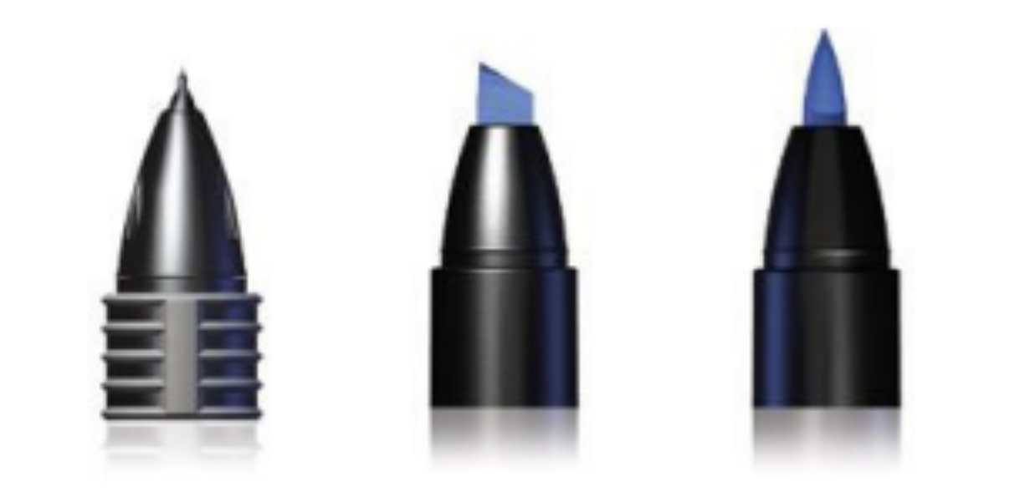

Fig. 3. From left to right: ultra-fine nib, chisel nib and brush nib

* The Ultra-fine nib is used for fine detail. There is a sharp point with a consistent flow to pin point fine line accuracy.
* The Chisel nib is predominantly used for a quick visual with a large colour fill. The nib will give a different line weight depending on which edge is used.
* The brush Nib is used for detailed fluid line drawing. An individual line can be widened or narrowed depending on the brush angle and the weight applied.

## Rendering with promarkers

Rendering with ProMarkers is a powerful technique for bringing illustrations, designs, and concepts to life with vibrant, smooth colours and professional-quality finishes. The dual-tip markers (broad chisel and fine bullet nibs) allow designers to create precise details as well as large, even colour fields. Below is an overview of rendering techniques using ProMarkers, which can be applied across various types of artwork, including rendering one point perspectives of Interiors, or a technical drawing of a floor plan.

### Applying colour

After applying a single layer of colour to the paper you will get an uneven colour finish.

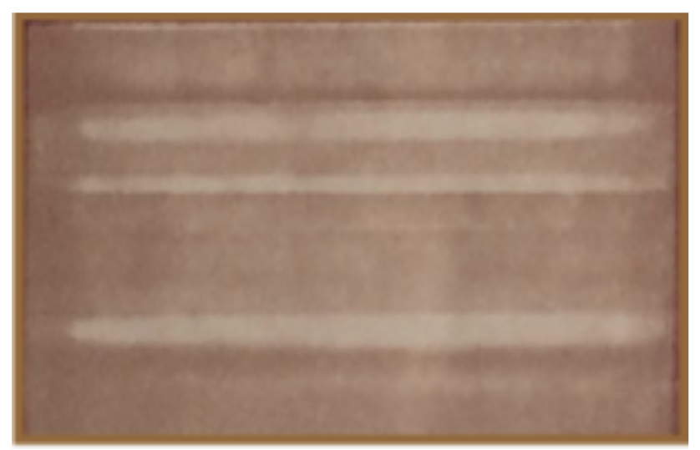

Fig. 4. 1st layer of colour applied

In order to counter that result you can either blend the colour together with a cotton bud or apply a second layer of colour as shown below:

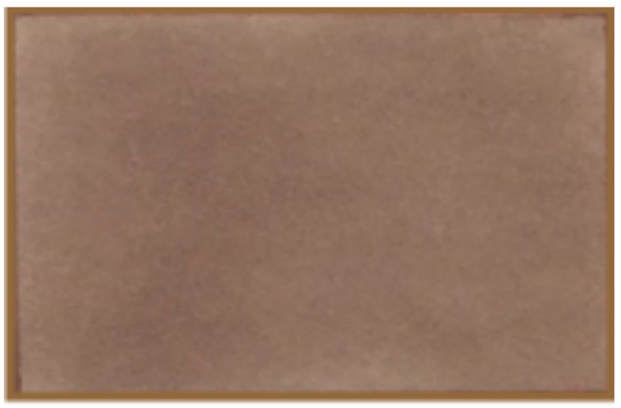

Fig. 5. 2nd layer of colour applied

## Blender Pen

The blender pen is mainly used to blend or fade colours. A coating of blender applied to the paper surface keeps the ink wetter for longer, allowing the colour to be more malleable. To use the blender pen, you must first apply it to the paper. Note: it will come out clear. Next, you apply the main colour.

In this example, the blender pen was applied to the left half of the image only, the cinnamon pen was then applied to the entire area. The difference in the intensity of the colour is clearly visible even with only a single layer of the cinnamon colour applied.

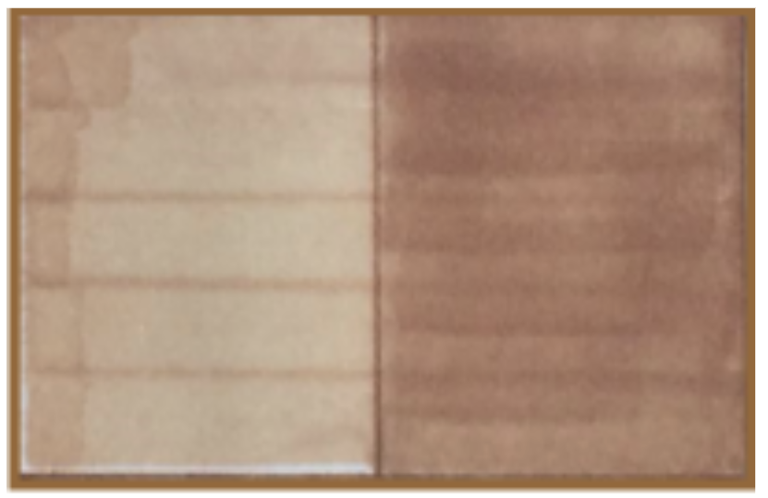

Fig. 6. Using the blender pen

## Using promarkers and colouring pencils together

You can use a white colouring pencil to change the tone of the promarker. In the examples below, a white colouring pencil is overlaid on the promarker to make the colour appear lighter. To achieve a darker colour, apply a darker colouring pencil on the promarker.

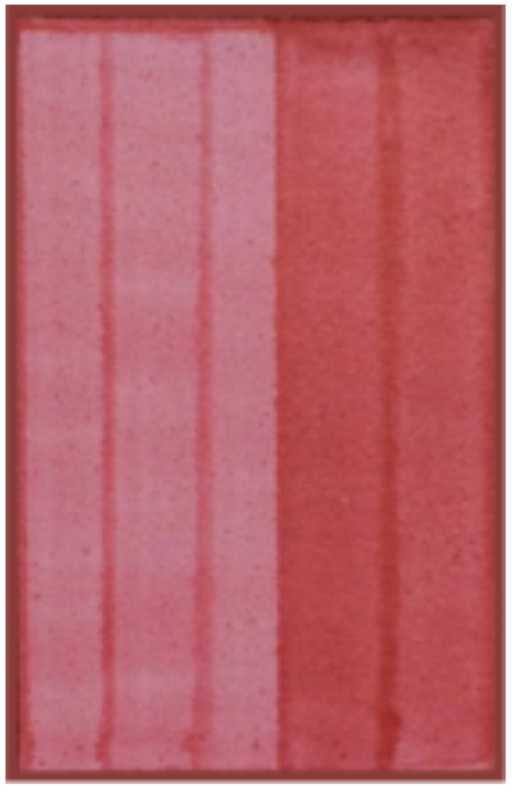

Fig. 7. Promarker (Cardinal Red) applied to paper with a build up of colour intensity.

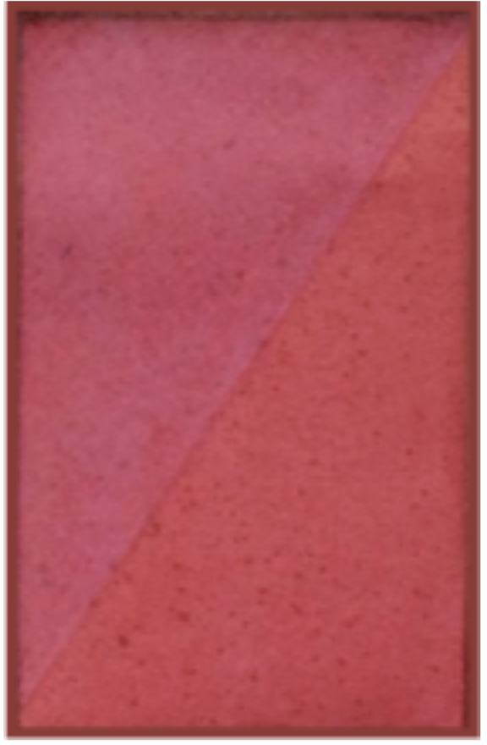

Fig. 8. A further layer of Cardinal red applied to paper followed by a white colouring pencil overlay.

## Linear gradient

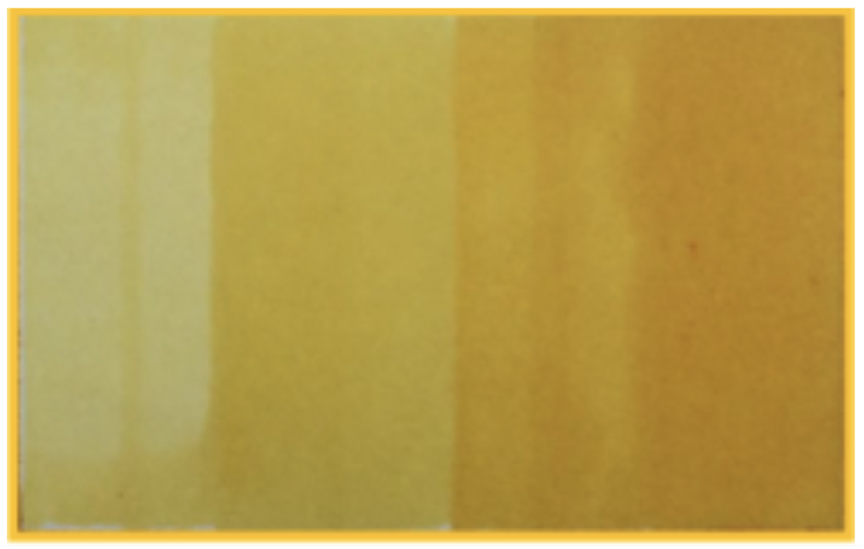

Fig. 9. Example of linear gradient from Yellow (left) to Tulip Yellow (right)

The colour gradient or colour progression is showing a span of colour from yellow to tulip yellow along a linear scale. The colour is shown by a graduated progression of a smooth colour transition from one to the next.

## Rendering techniques

### How to create a ceramic wall tile

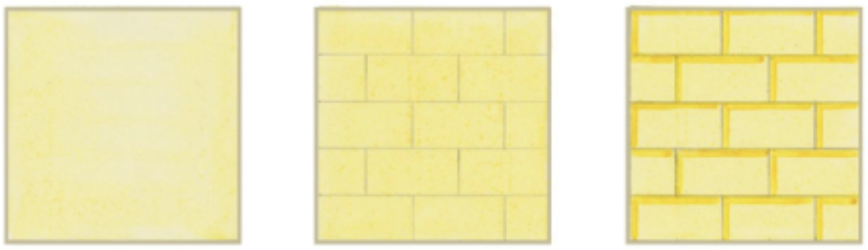

Fig 10. Step 1 (left), step 2 (middle) and step 3 (right)

#### **Step 1**

Firstly using the chisel or brush nib apply a single layer of Yellow marker. It is important to remember that in order to render each shape, you must try to use straight lines that do not overlap each other where possible. Then blend the colour together using a cotton bud. If you want a deeper colour you can apply a second layer of Yellow marker.

#### **Step 2**

Using a fine tip drawing pencil draw the outline of the tile shape you want. It is important to remember to allow the marker to fully dry prior to completing step 2 or 3.

#### **Step 3**

Now using the brush nib of the darker Tulip Yellow, simply draw a line along the top and down the left hand side of each tile

**Note:** Use a ruler to draw the outline of each tile in step 2, and to apply the Tulip Yellow marker in step 3.

### How to create a glass wall tile

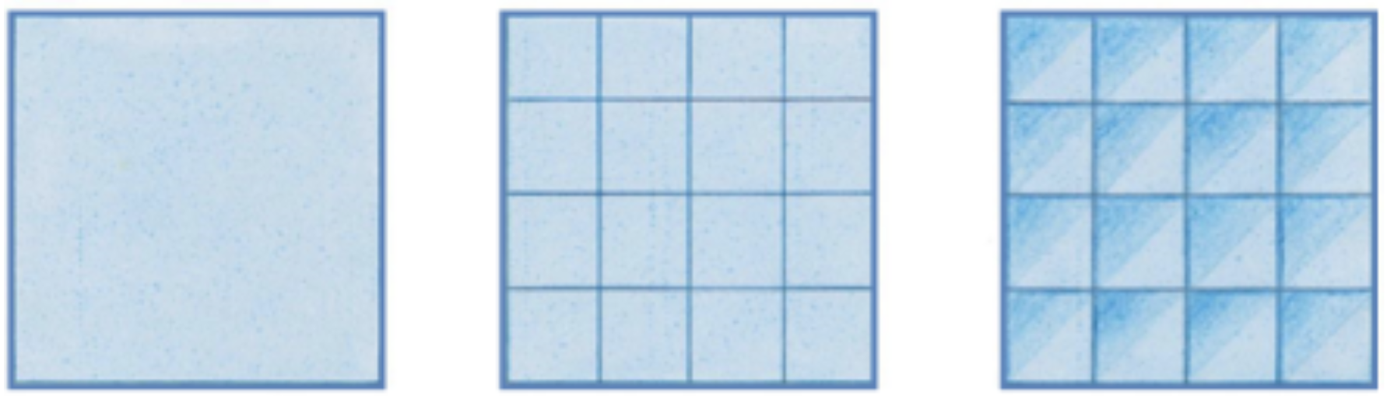

Fig 11. Step 1 (left), step 2 (middle) and step 3 (right)

#### **Step 1**

Firstly, using the chisel or brush nib, apply a single layer of Cool Aqua marker. Then blend the colour together using a cotton bud. If you want a deeper colour you can apply a second layer of Cool Aqua.

#### **Step 2**

Using the ultra-fine nib of the darker Cyan marker, draw the outline of the tile shape you want. It is important to remember to allow the marker to fully dry prior to completing step 2 or 3.

#### **Step 3**

Now divide the tile into two along the diagonal. Using a Light Blue colouring pencil, shade in the top half of each tile. Then using a slightly darker blue colour, shade over the top quarter of each tile.

## How to create a terracotta floor

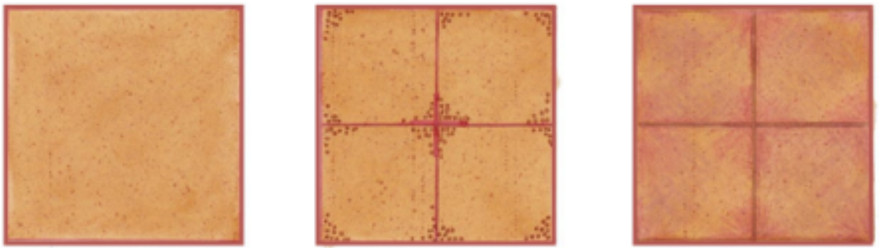

Fig 12. Step 1 (left), step 2 (middle) and step 3 (right)

#### **Step 1**

Firstly, using the chisel or brush nib, apply a single layer of Terracotta marker. Then blend the colour together using a cotton bud. If you want a deeper colour you can apply a second layer of Terracotta marker.

#### **Step 2**

Using the ultra-fine nib of the brighter Cardinal Red marker, draw the outline of the tile shape you want. Then using the ultra-fine nib of the Terracotta or Cardinal Red marker and the stippling technique, add in a series of dots to the corner of each tile.

#### **Step 3**

Using the ultra-fine or chisel nib of the Terracotta marker, draw the outline of the tile shape you want. Then using an Orange and Red colouring pencil, shade over a slightly different area on each tile. This will create a more natural appearance to the finished tile

## How to create a cube

#### **Step 1**

* Draw a cube using a ruler to ensure the shape is drawn correctly.

**Note:** use the Caramel marker for this. Then determine the direction of the sun and draw the outline of the shadow. Note: A Sandstone marker was used for this example. The direction of the sun is indicated by the arrow.

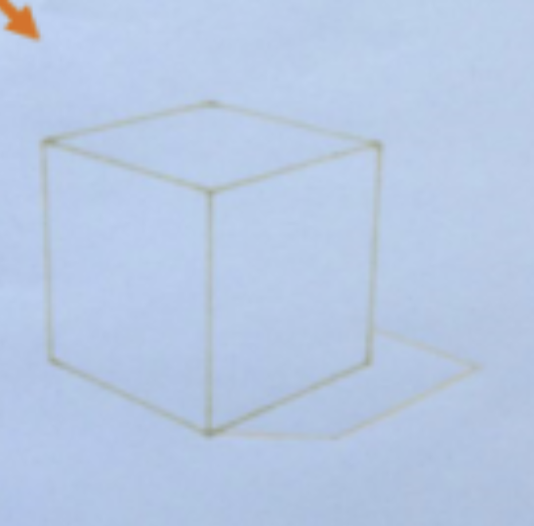

Fig. 13. Step 1

#### **Step 2**

* Now you are ready to start introducing a little colour onto the cube. Firstly, using the chisel or brush nib, apply a single layer of Yellow marker to the top and side of the cube nearest the sun. Then blend the colour together using a cotton bud.
* For the side of the cube you want to get a slightly deeper colour, you should apply a second layer of Yellow marker. Then for the side of the box furthest away from the light source, apply a layer of Tulip Yellow.
* Using the chisel or brush nib, apply a single layer of the Sandstone marker to the shadow area cast by the box.

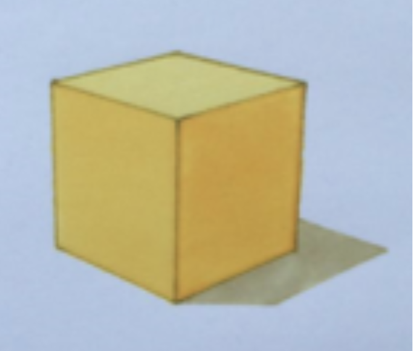

Fig. 14. Step 2

#### **Step 3**

* For the last step you can start introducing colouring pencils and using the layering technique. But remember to build up the colour gradually starting with your lightest colour. Note: Yellow and Orange are used to add shadow to the cube.
* Keep in mind that the sun is hitting the top of the cube and the gradient of colour will go from light to dark as you move further away from the light source.
* Finally you can draw the outline of the box again, giving the shape slightly more definition

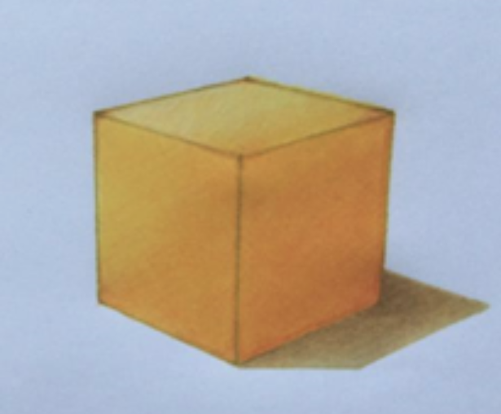

Fig. 15. Step 3

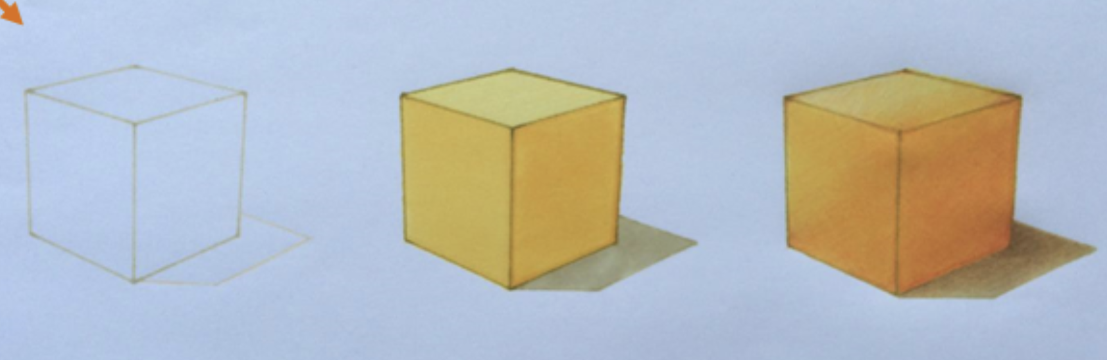

Fig. 16. Overview of how to create a cube

## Final Tips for using Promarkers

* **Test colours:** Always test your colours on a scrap of paper before applying them to your artwork to ensure they blend or layer as expected.
* **Work quickly:** Since ProMarkers are alcohol-based, the ink dries quickly, so it’s important to blend colours while they’re still wet.
* **Use the right paper:** Use smooth, bleed-proof marker paper for the best results. It allows the markers to blend smoothly and prevents the ink from soaking through to the other side.
* **Layer gradually:** When layering colours, always start with lighter tones and gradually build up darker shades to avoid over-darkening too quickly.

Below, you can find helpful online tutorials to help you practising your Promarkers skills:

[How to draw textures - Part 1](https://www.youtube.com/watch?v=9of1DAJWgWw)

[How to draw textures - Part 2](https://www.youtube.com/watch?v=5qXFAJPyd6Q)

[Floor plan in 10 easy steps](https://www.youtube.com/watch?v=Sr11QysfumM)

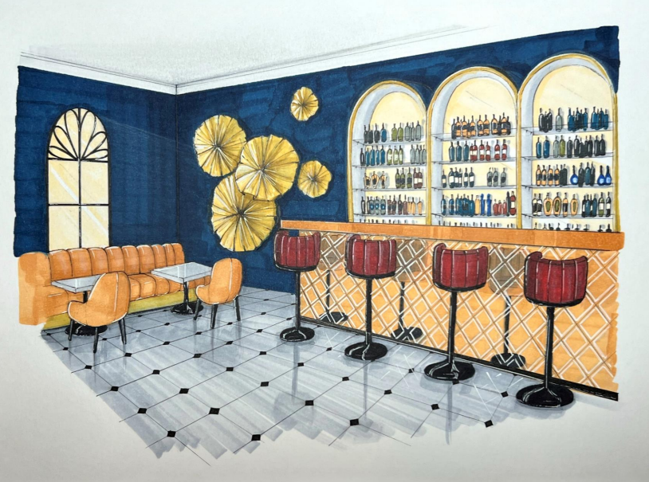

Fig. 17. Student Example (2022), Bar hotel drawing

Promarkers offer a powerful toolset for interior design students to effectively communicate their creative vision. Their vibrant colors and smooth blending capabilities empower you to explore and define your color schemes with precision and realistically depict the textures and surfaces of interior elements. With practice, you can confidently illustrate furniture forms and decorative details with accuracy. Mastering Promarker techniques elevate your visual communication skills and allows you to produce professional-quality renderings for presentations and design boards, bringing your interior design concepts to life with impact and artistry.